**GitHub Projects User Guide**

Contents

Purpose 1

Accessing Project documentation 1

Getting to your Project 1

Creating an Issue 3

Tracking Milestones 4

Tracking Risks 5

# Purpose

This guide outlines how the GitHub Projects feature will be used to manage individual projects.

The normal process and procedures will apply to the rest of the GitHub features that are commonly used to build and deliver code.

# Accessing Project documentation

1. Go to: [CEDS Collaborative Exchange (github.com)](https://github.com/CEDS-Collaborative-Exchange)
2. Navigate to the center of the Overview tab where you will find documentation such as:
   1. GitHub Projects guide: A step-by-step tutorial on how to manage you are your Project.

# Getting to your Project

Your repository will be set up and accessible under this tab. Access will be set up once the roles and responsibilities are defined, and kickoff is completed.

1) Click on the ‘Repositories’ tab

2) Select the project name

1. Navigate to the ‘Projects’ tab under your repository

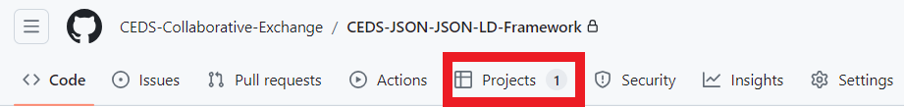

1. Select the Project

1. The Project Board will display and is based on status columns where project issues will be managed and tracked.

# Creating an Issue

1) Click ‘+ Add Item’ at the bottom of the status column where the issue applies

2) Type in a description and hit ‘Enter’

3) Convert the ‘Draft’ issue to an ‘Issue by clicking on the ellipsis in the ticket

4) Select the associated repository

5) Be sure the following fields are populated:

* Assignee: Person responsible for ticket
* Labels: Type of issue
* Milestone: Milestone (phase) the issue is associated with

1. If you want certain fields to display on the issues for better visibility you can configure the board and select the fields to show

# Tracking Milestones

1. Click on the ‘Issues’ tab
2. On the far right click on ‘Milestones’

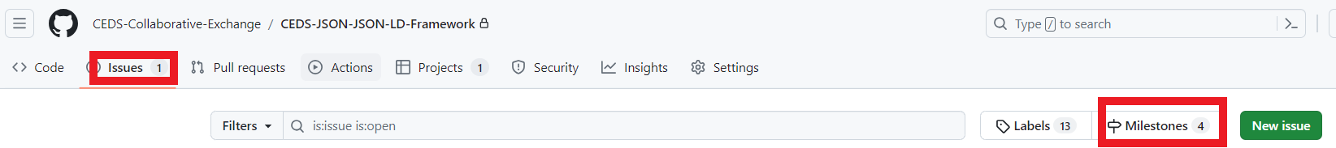

1. There will be five milestones tied to every project. Treat the milestones like phases and will feed into your project timeline.
   1. Community Review - Requirements/Design
   2. Community Review - Development
   3. Community Review - Testing
   4. Community Review - Ready for Public
   5. Community Review - Deploy to Public
2. Add delivery dates to each based on your project timeline
3. You can track and report on the status of each milestone throughout the project timeline



# Tracking Risks

1. Click ‘+ Add Item’ at the bottom of the Risks column
2. Type in description and hit ‘Enter’
3. By default, the item will be created as a ‘Draft.’ A ‘Draft’ is different than an ‘Issue’ because you do not need any code associated with it. All Risks will be left as ‘Draft’ issues.
4. Add an assignee

